***Repeater Building Hints and Tricks***



*AGRG Trustees - 2023*

**Audio Chain 2**

Using Data Input as Mic Input 2

**RF Chain 3**

Fitting an “N” Male on a “UHF” Female 3

**Controllers 4**

Build a Controller Replacer 4

**Power 5**

**Misc. / Didn’t fit elsewhere 6**

Label Makers 6

# Audio Chain

## **Using Data Input as Mic Input**

You can use the TX Data input as a non-emphasized microphone audio input on most Kenwood radios (TK-862, TK-880,etc) and possibly other radios.

The issue is the PL tone encode. Even though you may have it programmed, it will not show up due to where you have injected the audio. There is a simple solution to this.

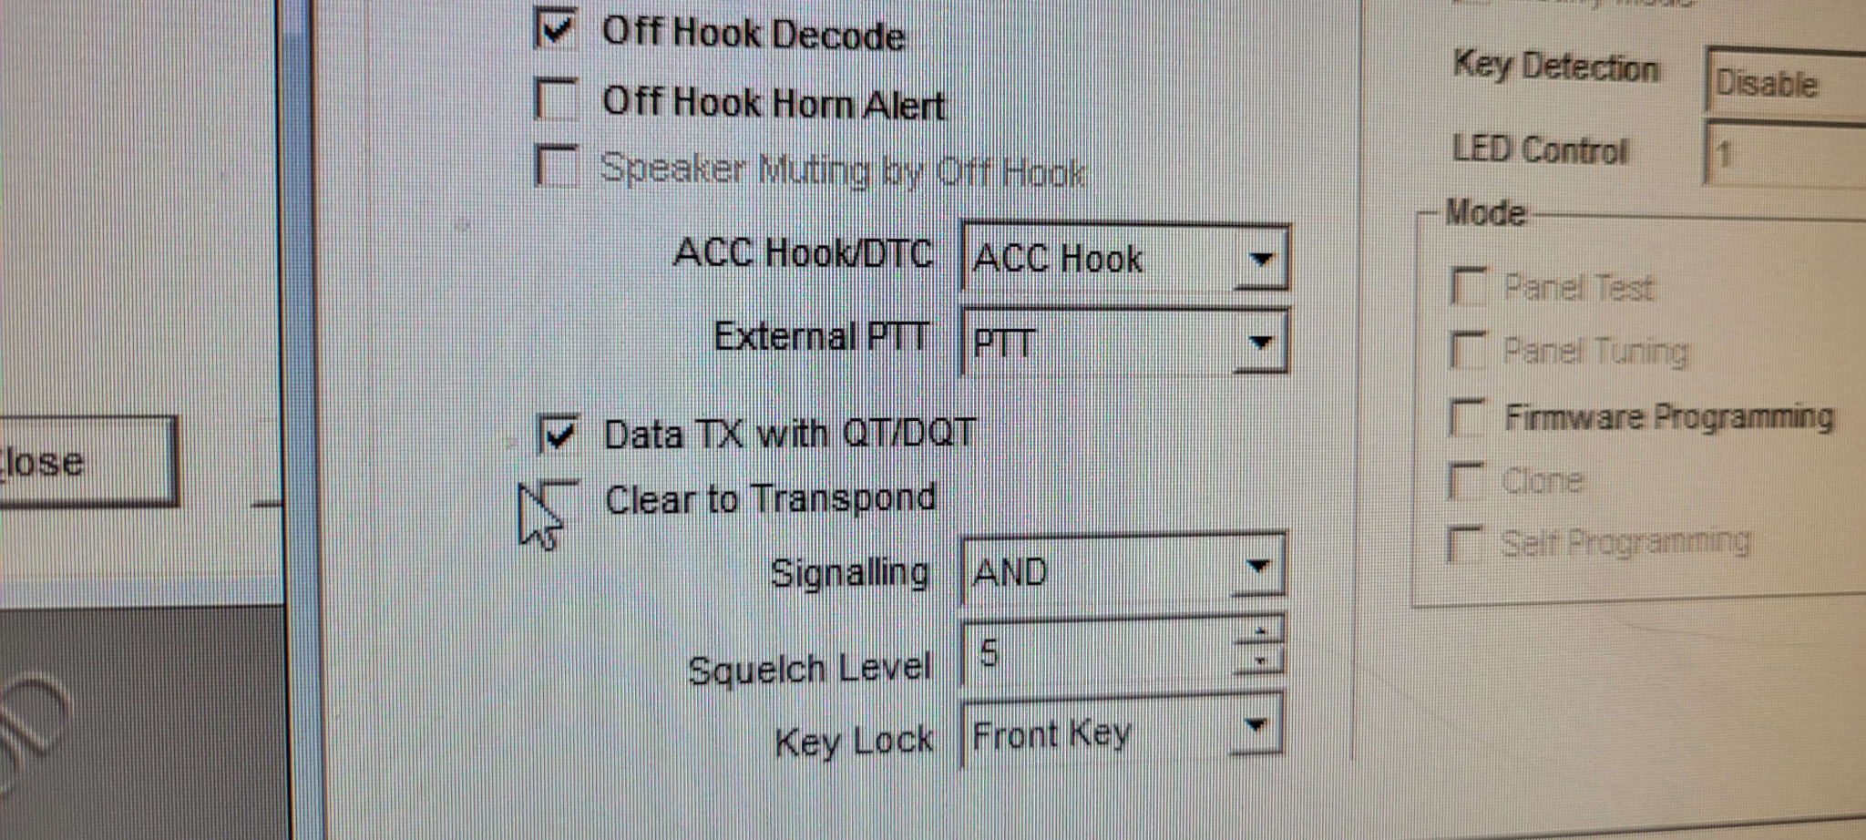

Under “optional features” ensure that Data TX with QT/DQT (PL Tone) is enabled. Problem solved.

If you use raw audio from the discriminator, that will still have the PL tone superimposed. If you feed that signal to this data input, it will retransmit the PL tone that was originally encoded by the user’s radio. In other words, the audio isn’t scrubbed off. That allows for less audio processing where the RC filters aren’t exactly perfect anymore to change audio quality.

-Jon Williams K5DVT/WRKG942 8/20/2023

# 

# RF Chain

## **Fitting an “N” Male on a “UHF” Female**

You can make a N male fit on a UHF Female for you are absolutely in a pinch. This should only be used temporarily. I have one on a link radio and it’s been working well for over a year now.

The thread of the shells on both connectors are the same. In order to get the N to go into the UHF connector, you will need to very carefully remove the ground ring around the center pin of the N connector without damaging the inner pin. I use a flat head screwdriver to bend each “leaf” of the shield ring to the shell. Then I bend it back. After repeating this a few times the leaf will fall off. With a propper 50 ohm N connector you’ll have 4 leaves. When you mate the two connectors, be sure to be gentle with aligning them up. The inner pin is a bit skinny, but also fragile. It will make contact when the point reaches the bottom of the UHF female pin cavity, but also when it is deep enough usually the body of the pin will make contact with the wall of the cavity.

-Jon Williams 8/20/2023

# Controllers

## **Build a Controller Replacer**

This is a plug that acts as a substitute repeater controller. This is useful if you are troubleshooting the controller, or if the controller dies and you need a replacement. Be aware this doesn’t ID, but you could add a pot to add simple audio level control. The COR is tied to the PTT line, and the RX audio out is tied to the TX audio in. All grounds must be connected to ensure that no matter which ground pin you use (some cables have multiple) the grounds are the same.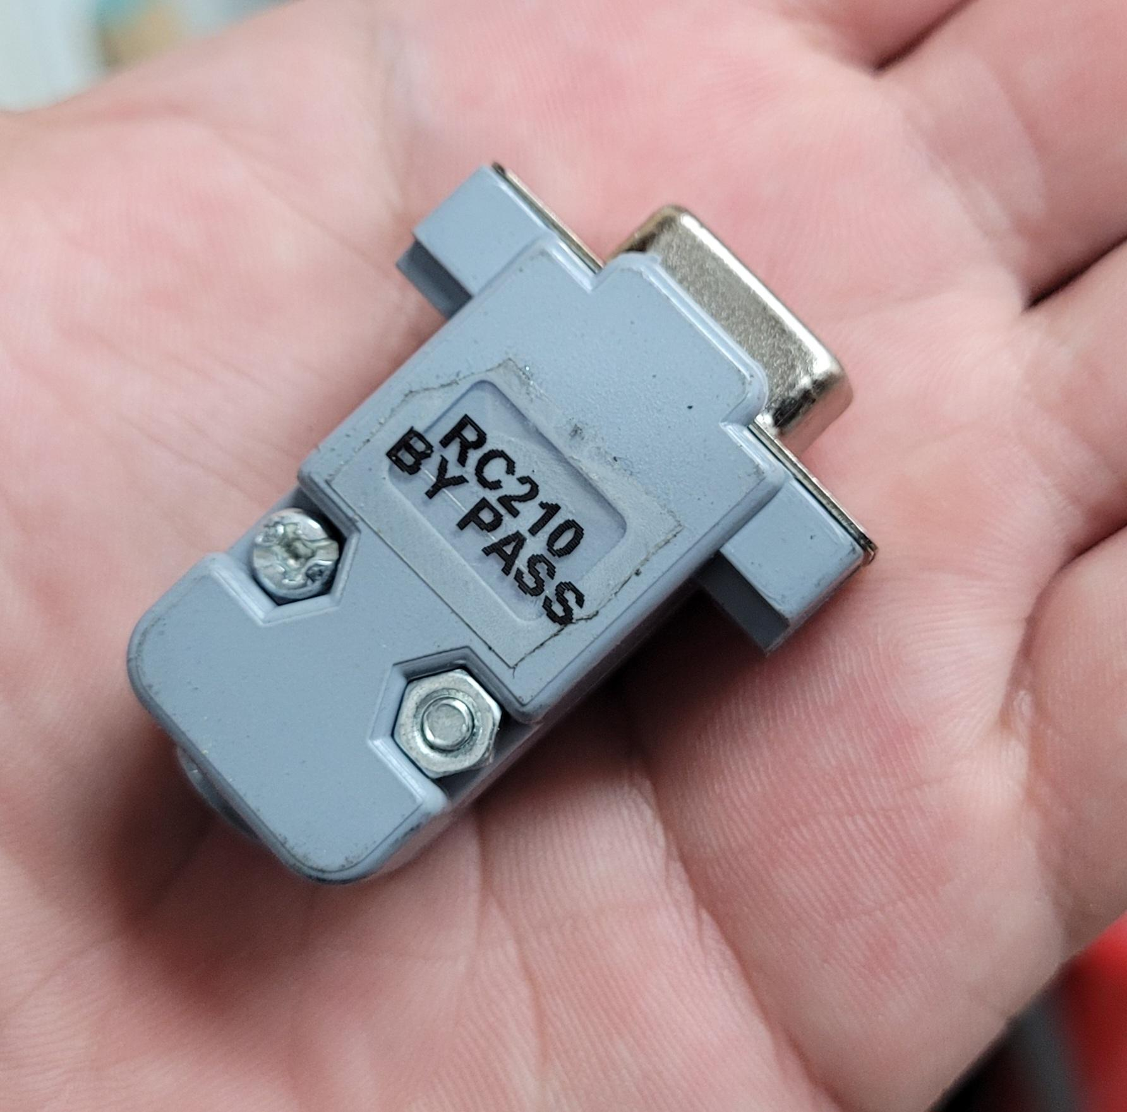

I leave this plug in my adapter box which I bring with me to every repeater site. I may not be able to fix the controller, but at least I have a low cost solution to band aid it.

-Jon Williams K5DVT/WRKG942 8/20/2023

# Power

# Misc. / Didn’t fit elsewhere

## **Label Makers**

Use them! - JW